ECE 491 - Python Lab 2
Basic Image Processing Using Python - Submission Report
Boat and Barbara appendix images used as the experiment inputs

Input Image and Normalization
The Boat image has shape (512, 512). It is read in grayscale, converted from uint8 to float32, and normalized by dividing by 255.
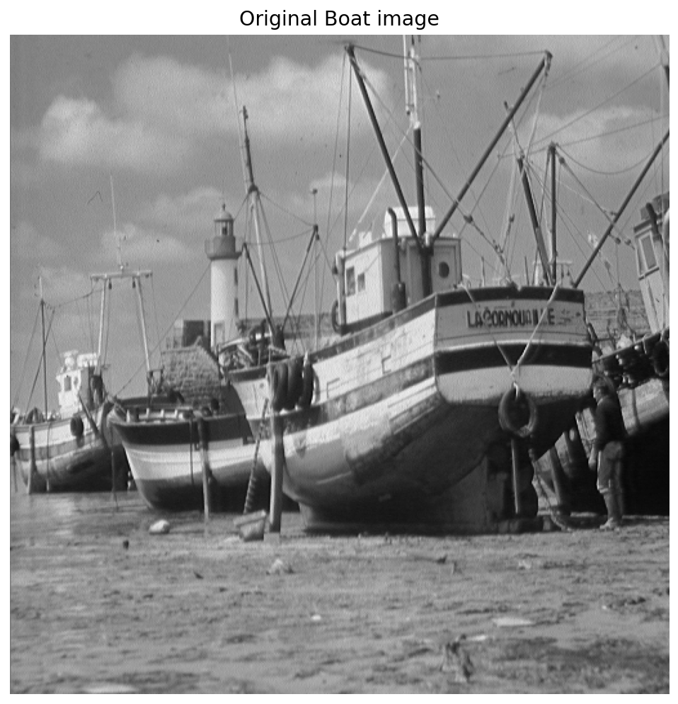
Figure 1. Original Boat image used for the grayscale experiments.

1) Pixel at Location (132,112)
Original uint8 value: 158.
After normalization: 158 / 255 = 0.6196078658.
NumPy indexing uses row 132, column 112.

2) Top-Left Quarter
Since the image is 512-by-512, half of each dimension is 256. Therefore a = 0, b = 256, and the required two-dimensional slice is:
img[0:256, 0:256]
The resulting quarter image has shape (256, 256).
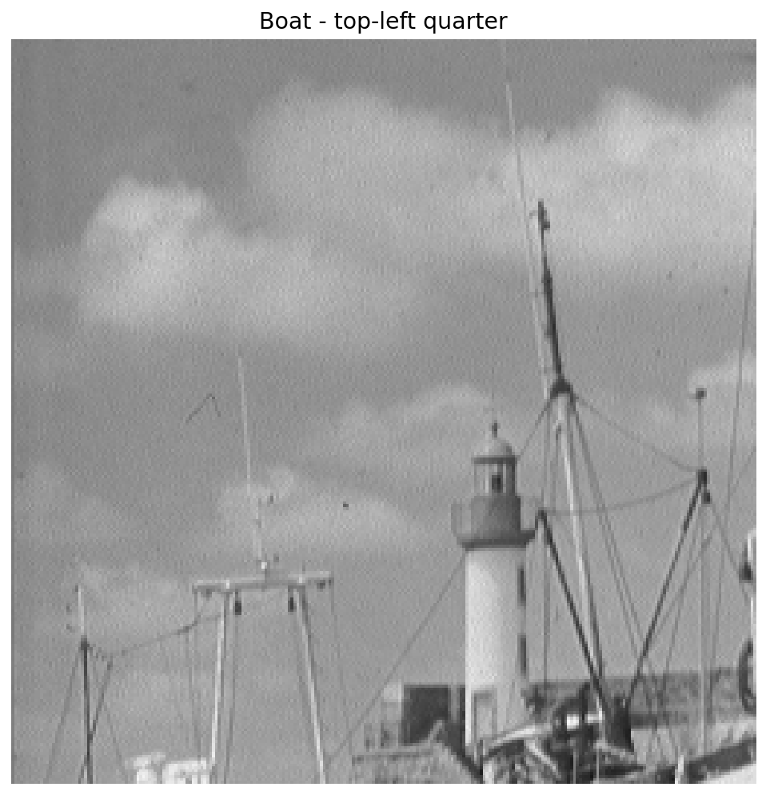
Figure 2. Top-left quarter of the Boat image.

3) 3-by-3 Moving-Average Box Filter
The moving-average filter is (1/9) times a 3-by-3 matrix of ones. Because scipy.signal.convolve2d is used without an explicit mode, the default mode='full' is applied.
For a 512-by-512 image convolved with a 3-by-3 filter, the output size is:
(512 + 3 - 1) by (512 + 3 - 1) = 514 by 514.
Visual comparison: the filtered image is smoother and slightly blurred relative to the original. Sharp edges are softened and fine texture is reduced. This is the expected low-pass behavior of a moving-average box filter.
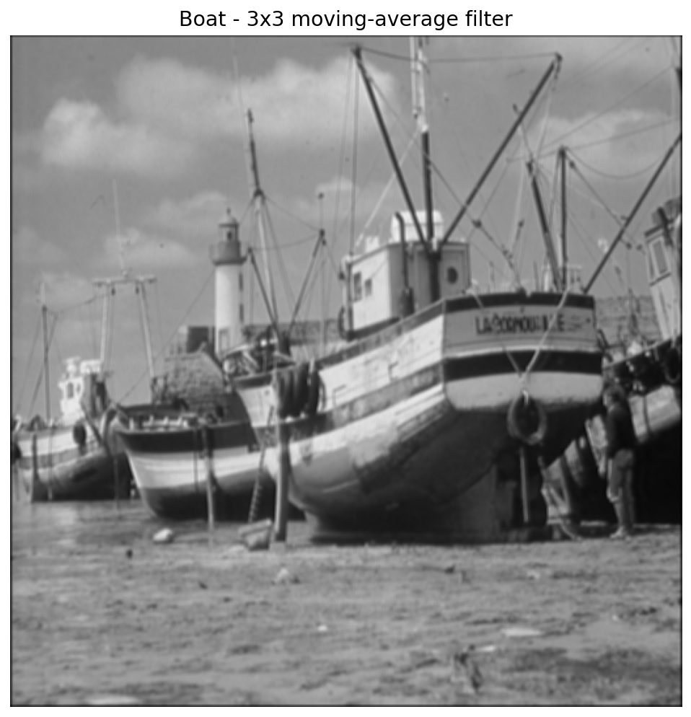
Figure 3. Boat image after 3-by-3 moving-average filtering.

4) Save the Filtered Image
Before saving, the filtered floating-point image is clipped to [0,1], scaled to 0-255, converted to uint8, and written with cv.imwrite. This preserves the displayed brightness in the saved PNG.
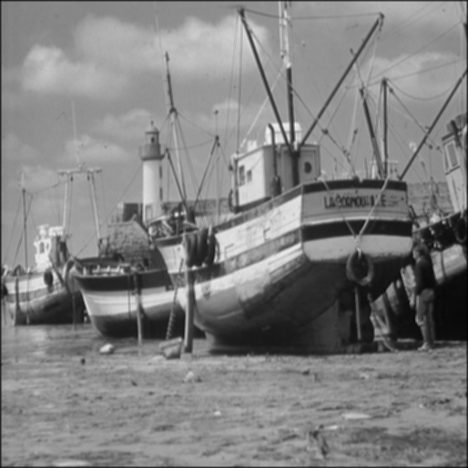
Figure 4. Saved moving-average Boat image verified from disk.

5) 3-by-3 Difference Filter
The requested filter is:
1 | 0 | -1
2 | 0 | -2
1 | 0 | -1
This filter emphasizes intensity transitions and produces both positive and negative values. Following the handout, 0.5 is added to the output before display and the displayed result is clipped to [0,1]. Flat regions remain closer to mid-gray while edges produce stronger contrast.
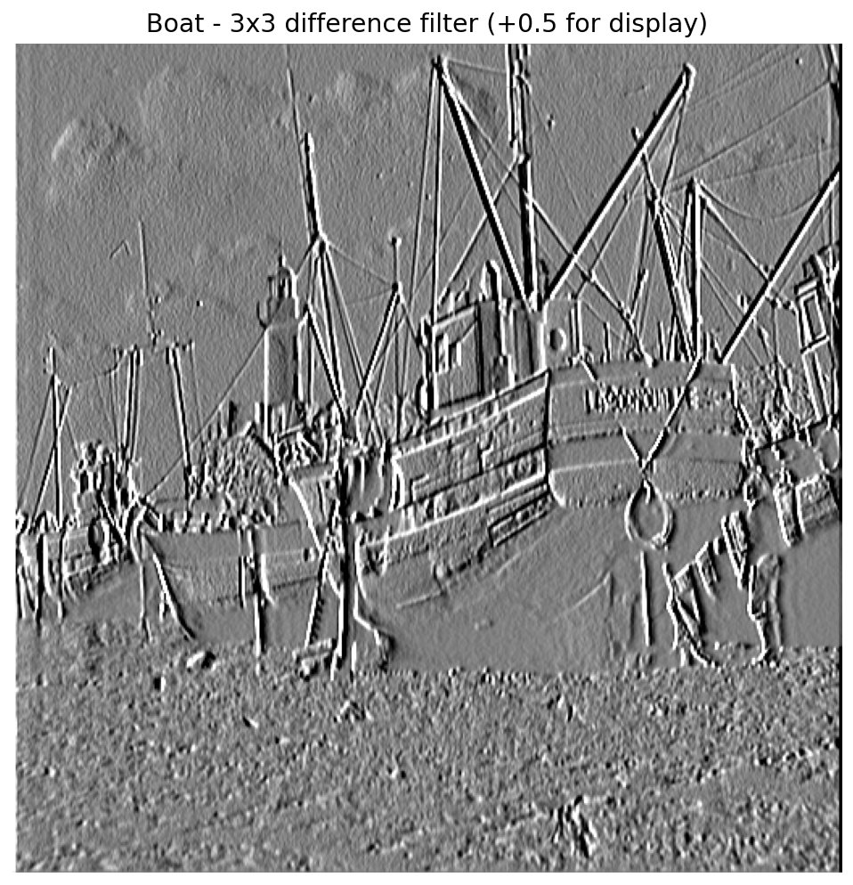
Figure 5. Boat image after the 3-by-3 difference filter.

6) Horizontal-Edge Experiment
Following the handout exactly, the row filter [-1, 2, -1] is used. With full convolution, a 512-by-512 image convolved with a 1-by-3 filter produces an output of size (512, 514).
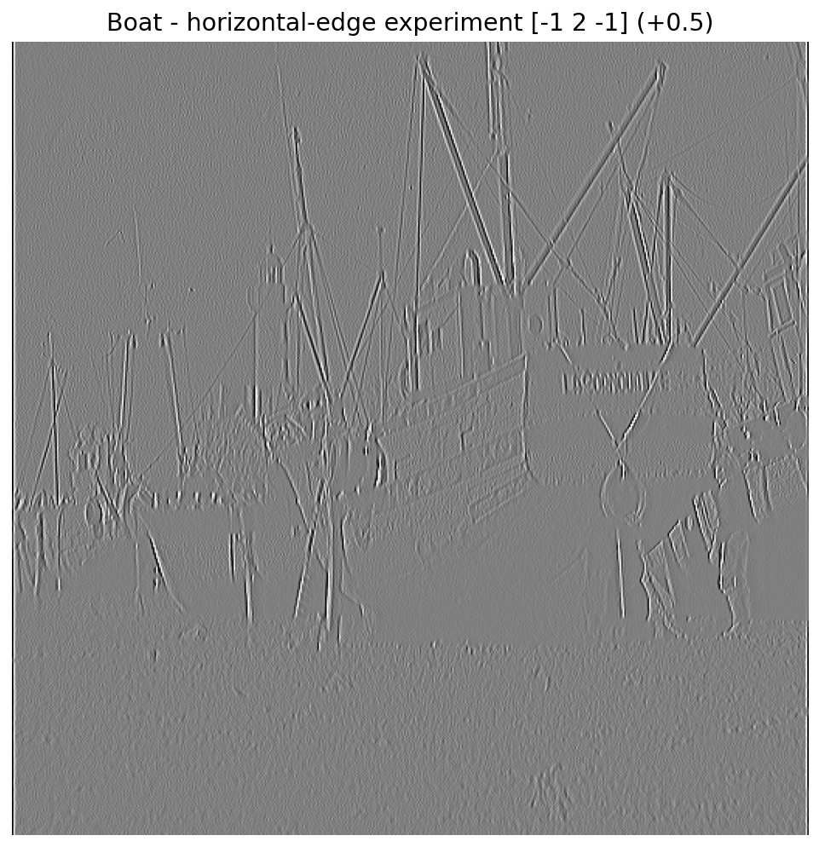
Figure 6. Horizontal-edge experiment using the row filter [-1, 2, -1].

7) Vertical-Edge Experiment
The transposed filter [-1, 2, -1]^T is used. With full convolution, the 3-by-1 filter produces an output of size (514, 512).
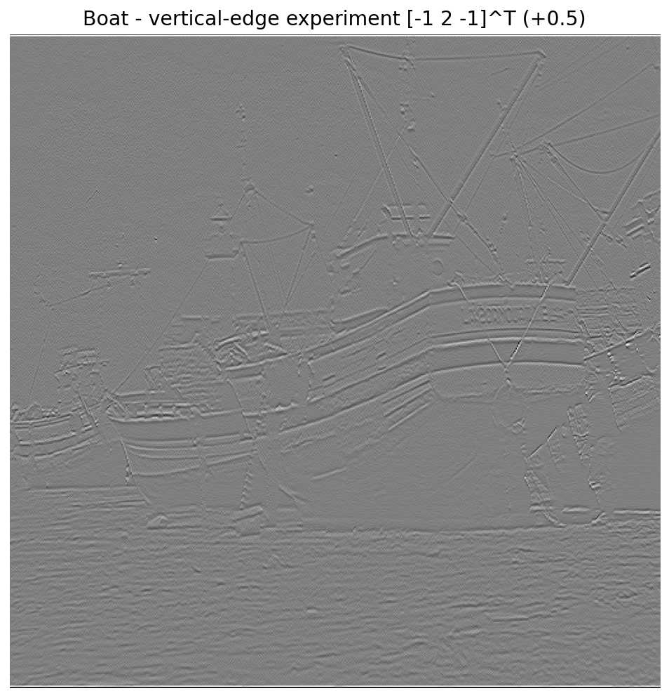
Figure 7. Vertical-edge experiment using the transposed filter.

8) Repeat the Experiments with the Color Barbara Image
OpenCV reads color images in BGR order. The Barbara JPEG is therefore converted with cv.cvtColor(img, cv.COLOR_BGR2RGB), converted to float32, normalized by 255, and the red, green, and blue planes are filtered independently.
Before an RGB result is saved with cv.imwrite, it is converted back to BGR so the saved colors are correct.
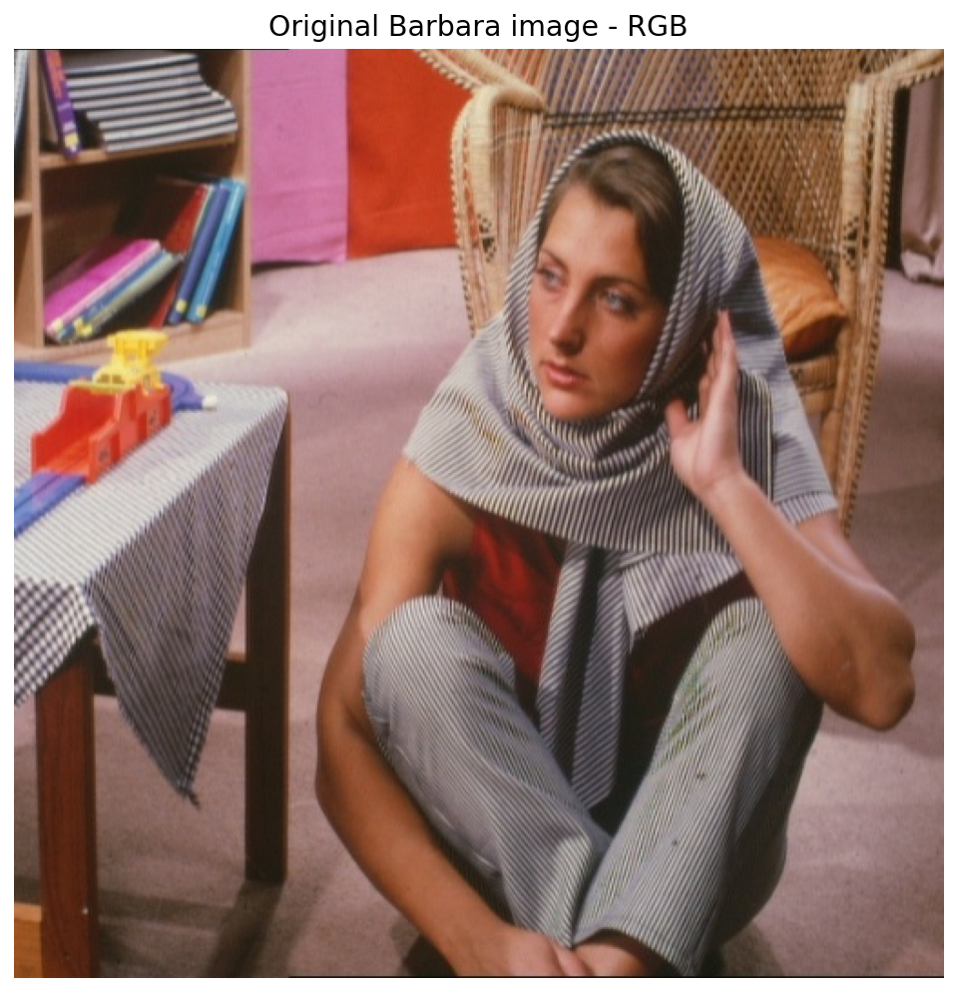
Figure 8. Barbara image after BGR-to-RGB conversion.
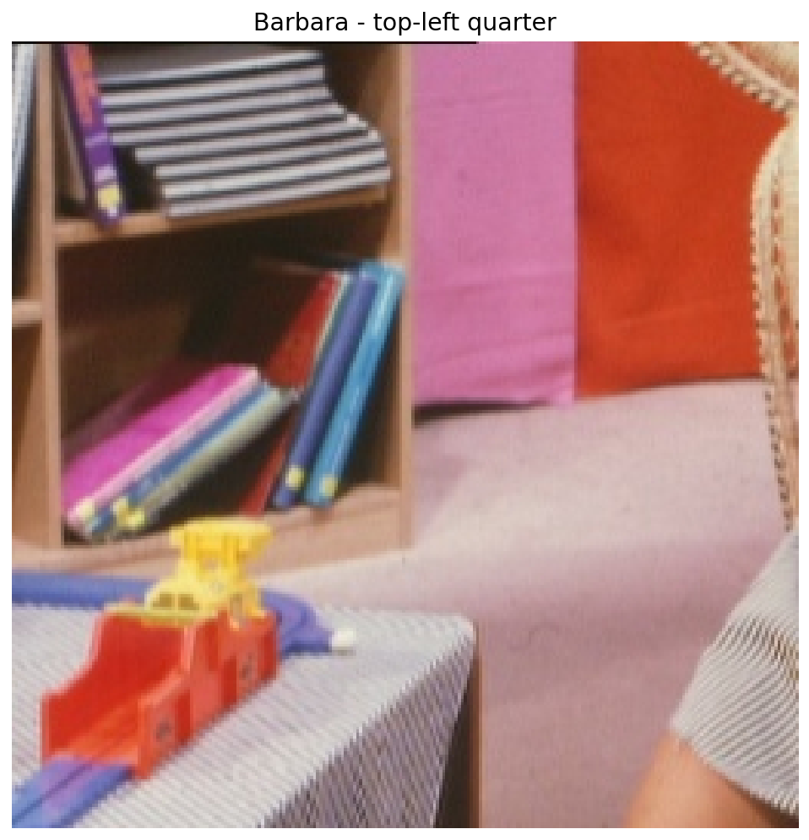
Figure 9. Top-left quarter of the Barbara image.

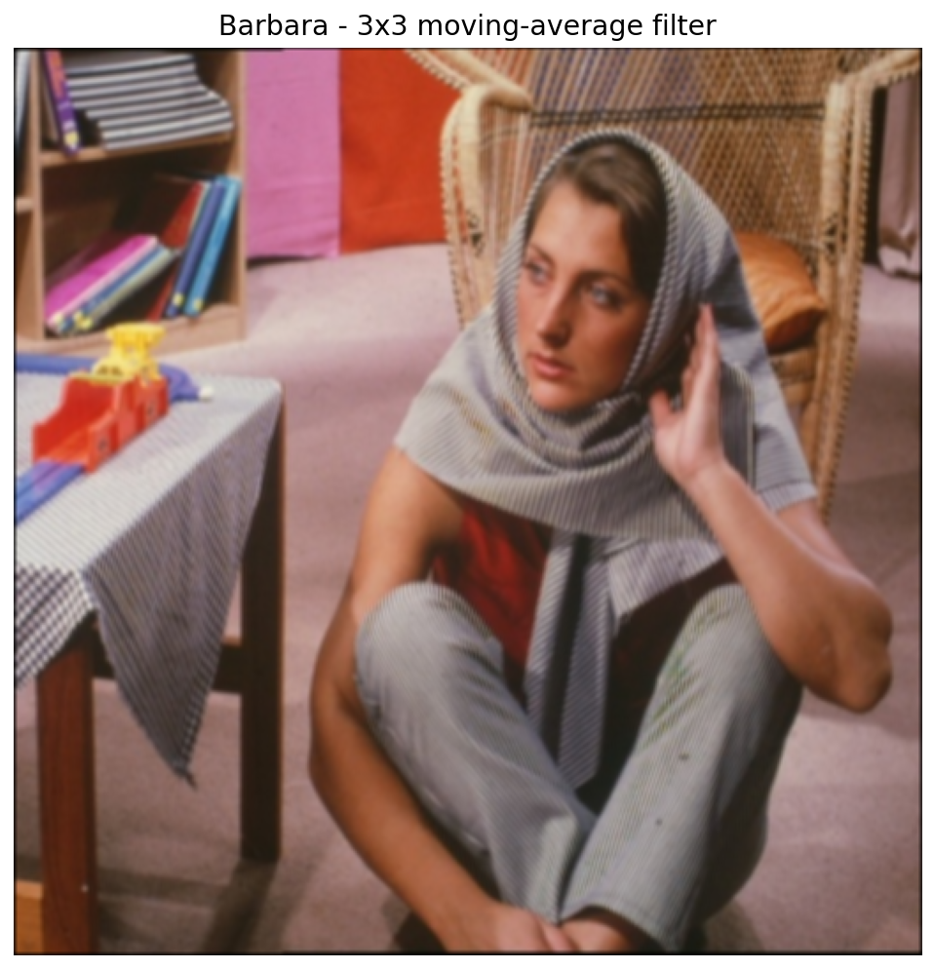
Figure 10. Barbara after 3-by-3 moving-average filtering. Fine texture and edges are softened.
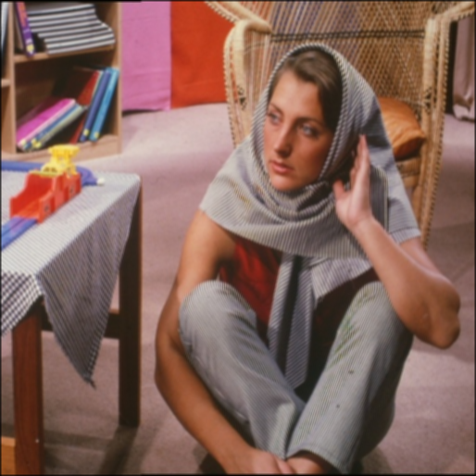
Figure 11. Saved Barbara moving-average image verified after RGB-to-BGR conversion.

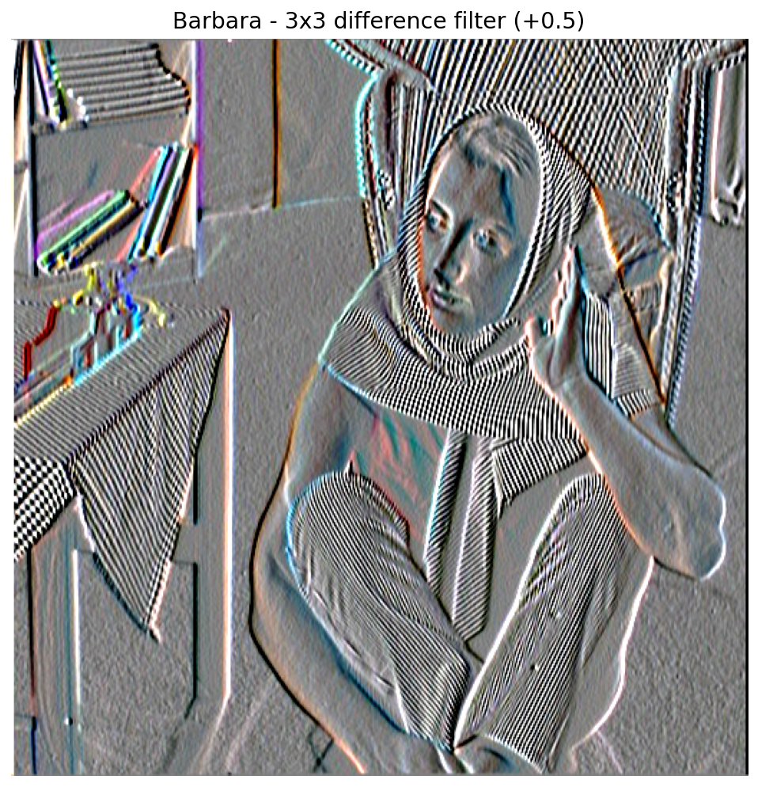
Figure 12. Barbara after applying the 3-by-3 difference filter independently to R, G, and B.
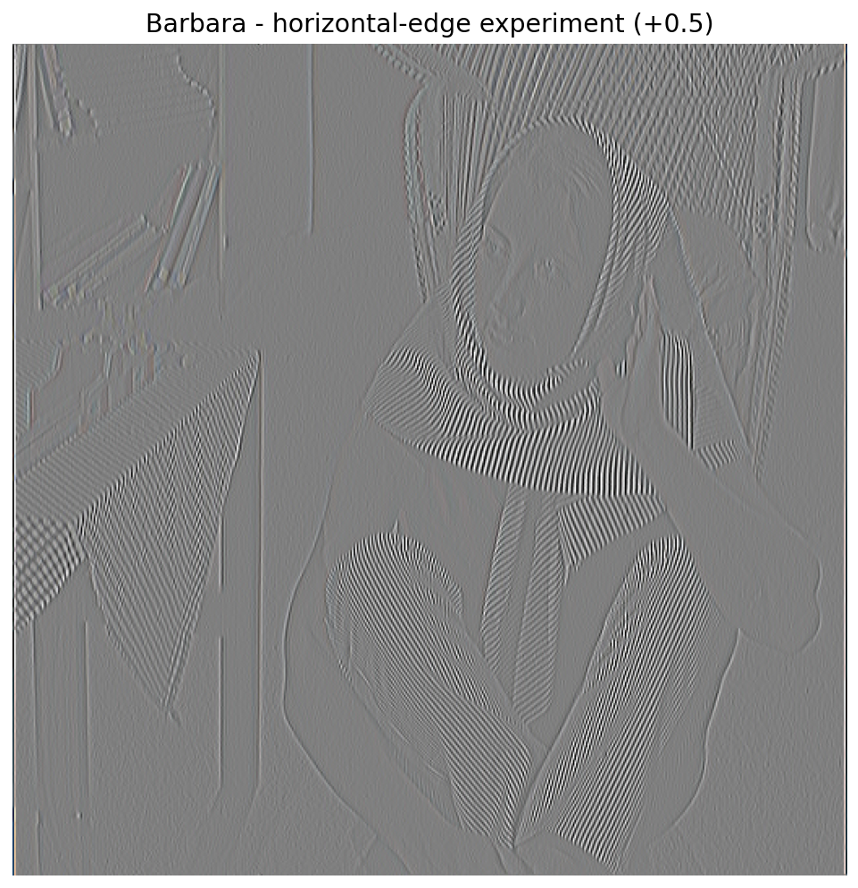
Figure 13. Barbara horizontal-edge experiment using the row filter [-1, 2, -1].

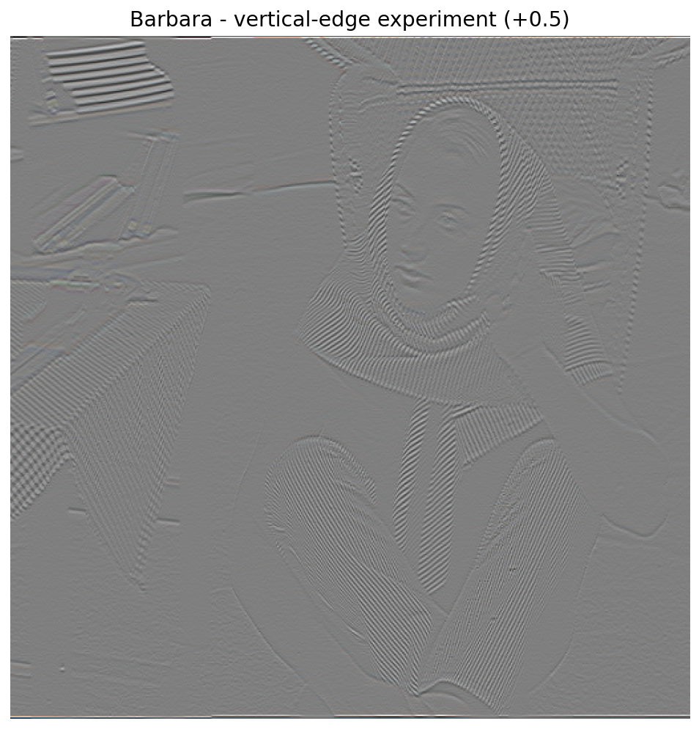
Figure 14. Barbara vertical-edge experiment using the transposed filter [-1, 2, -1]^T.

Final Verification Summary
Item | Verified Result
Boat shape | 512 x 512
Pixel (132,112) | 0.6196078658 after normalization
Top-left quarter | img[0:256, 0:256] -> 256 x 256
3x3 full convolution | 514 x 514
Row [-1,2,-1] full output | 512 x 514
Column transpose full output | 514 x 512
Barbara processing | BGR -> RGB; filter each R/G/B plane; RGB -> BGR before saving
All reported dimensions and values were obtained from the provided appendix images and the implemented Python processing pipeline.

